**Table of Contents**

**1   Introduction**

1.1       Purpose

1.2       Document Conventions

1.3       Project Scope

**2   Device Characteristics**

2.1       Barcode For process Completion

2.2       Barcode For process Failed/Reworked

2.3       Push button for count

2.4 LED indicators

**3   Work Flow**

3.1 Main Process

3.2 Steps

3.3 Identification Marker

**4 Requirements**

**5 Data Represented**

5.1 Dashboard

5.2 Station status

5.3 Track status

5.4 Track Shipment

5.5 Statistical Data

5.6 Compare Builds

**6 Notifications**

6.3 Display Notification

6.3 SMS Notification

6.3 Email Notification

**7 Test Cases**

**1. Introduction**

**1.2 Purpose:**

A streamlined Data tracker. A means to track products, create different statistical data and real time information of different items manufactured.

**Document Convention:**

|  |  |
| --- | --- |
| Abbreviation | Word |
|  |  |
|  |  |
|  |  |
|  |  |
|  |  |
|  |  |
|  |  |

**1.3 Project Scope:**

Data tracking for a streamlined manufacturing process so that corrections can be made to make the production process more efficient.

**2. Device Characteristics**

**2.1 Barcode for Process Completion:**

Barcode Scanner is used to track the movement of a product in a production line. This barcode scanner is blue/green to indicate that it should be used only if a process is passed.

**2.2 Barcode for Process Fail/Rejected:**

Barcode Scanner 2 is used to track failures for each station. This helps to rectify recurring errors in a station. This barcode scanner is color coded in red to scan the barcode of a failed product.

**2.3 Push Button for Count:**

Push button can be used for processes that do not support barcode traceability feature.

**2.4 LED indicators:**

There are 3 lighting schemes associated with the device.

* Green-Indicates the barcode has been accepted by the device
* Red- The Barcode scanner not connected to the device
* Blue-device is in sync with the server

**3. Work Flow**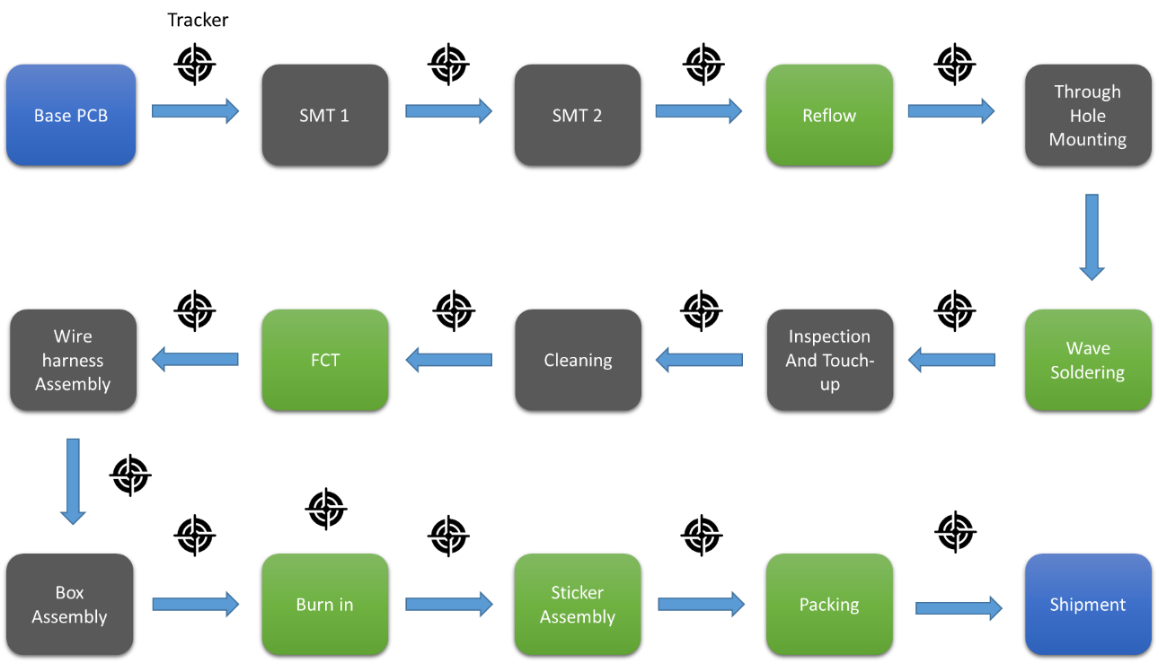

**3.1 Main Process**

* The production moves from Bare PCB through the production line to the Shipment with a barcode being attached on the bare PCB to identify each product
* After every stage, the product is scanned. For Burn in, product is scanned before and after the stage.
* If the product fails then the reject barcode scanner is used. The product is then sent to previous stages and brought back. Then scanned in the same order.
* Packing stage will have a PC to display and check if the product has gone through all the stages. Only after that it will be shipped and made as a passed product
* Shipping will have a pc and a form to submit the goods shipped

**3.2 Steps**

**Stage 1: Bare PCB**

* Barcode is added to the bare PCB

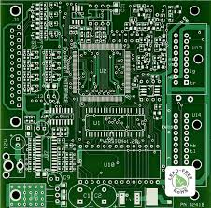

Device 1

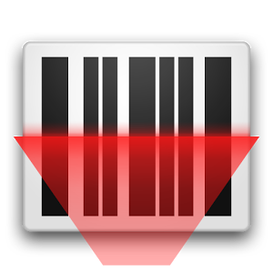

**Stage 2: SMT1**

Device 2

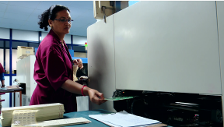

After SMT1, The PCB is scanned to show that the particular PCB has completed SMT1.

**Stage 3: SMT2**

Device 3

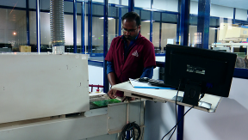



After SMT2, The PCB is scanned to show that the particular PCB has completed SMT2.

**Stage 4: Reflow**

Device 4

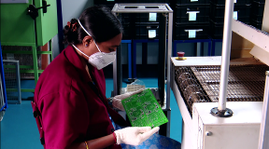



After Reflow, The PCB is scanned to show that the particular PCB has completed Reflow.

**Stage 5: Through-hole component mounting**

Device 5

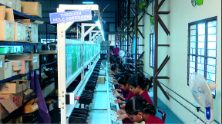



After each mounting, The PCB is scanned to show that the particular PCB has completed the stage.

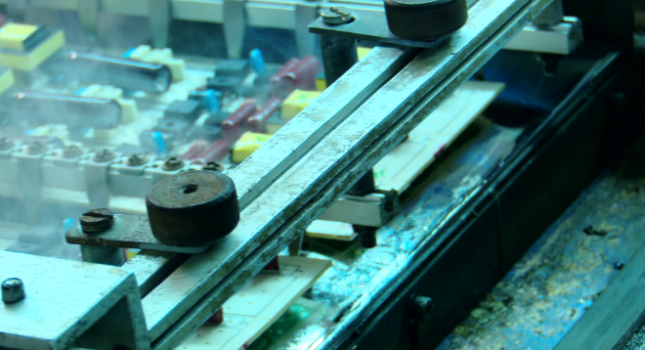**Stage 6: Wave Soldering**

Device 6



After each Wave Soldering, The PCB is scanned to show that the particular PCB has completed Soldering.

**Stage 7 Inspection And Touch-up**

Device 7

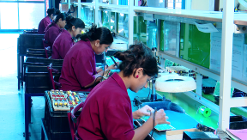



After each Inspection, The PCB is scanned to show that the particular PCB has been inspected.

**Stage 8: Cleaning**

Device 8



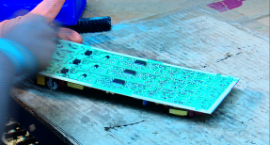

After each PCB is cleaned, The PCB is scanned to show that the particular PCB has completed cleaning.

**Stage 9: PCB Functional Test**

Device 9



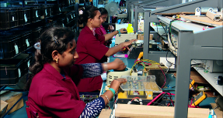

After each PCB is Tested, The PCB is scanned to show that the particular PCB has been tested functionally.

**Stage 10: Wire Harness assembly**

Device 10





After each Wire Harness assembly, the product is scanned.

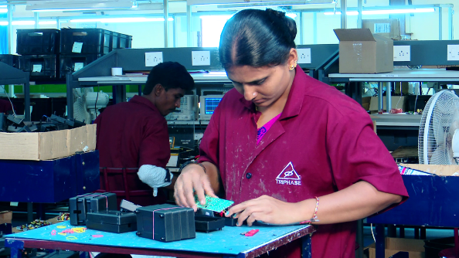**Stage 11: Box assembly**

Device 11



After each PCB is boxed-in, The PCB is scanned to show that the particular PCB has been boxed-in.

**Stage 12: Burn-in**

Device 13

Device 12

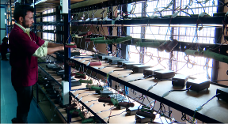



Before and after The PCB is tested by burn-in, the product is scanned.

**Stage 13: Sticker assembly**



Device 14 121212

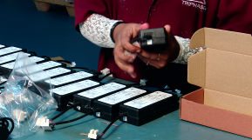

After Sticker is attached to the adapter, the product is scanned to show that sticker is attached

**Stage 14: Packing**

Device 15 121212

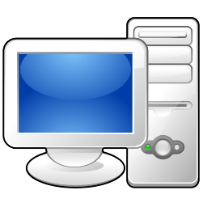

Device 16

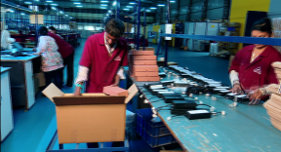



After Sticker Assembly, product is checked in a pc if it has completed all the processes.

**3.3 Identification Marker**

* + Each PCB will have a 4 digit Precursor in their barcode to identify the product.

**4. Requirements**

* Devices:16

One device acts as pc in shipping while the rest are for the barcodes

* Server PC

A server pc is used to control all the devices and store relevant information

* Wi-Fi Router:1

To connect all the devices

* Repeaters- based on size of production

To boost the connection between all the devices in a large plant

* Barcodes:16(15 pass and 1 fail)

15 barcodes are used to track the normal flow of manufacturing, while to track a faulty station 1 extra barcode can be attached to a device to track failures.

**5. Data Represented**

**5.1 Dashboard**

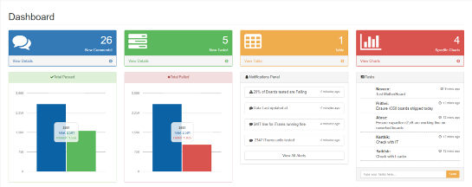

To get an overall idea of what is going on in the production setup

**5.2 Station status**

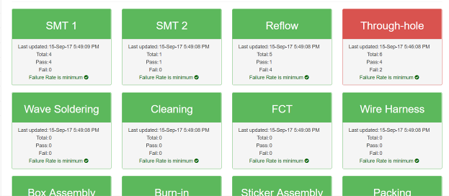

To get an on-a-glance view of the different stations, see if the devices are working, check failure rates for each device etc.

**5.3 Track status**

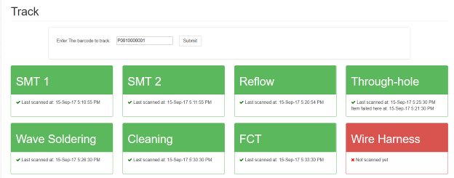

To track a particular product from its barcode. It shows all the stations a product passed through and at what time. This also displays if any product failed at a particular station

**5.4 Track Shipment**

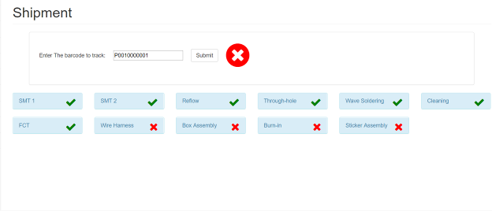

To track a particular product from its barcode up to the packing stage so that the product can be packed and shipped

**5.5 Statistical Data**

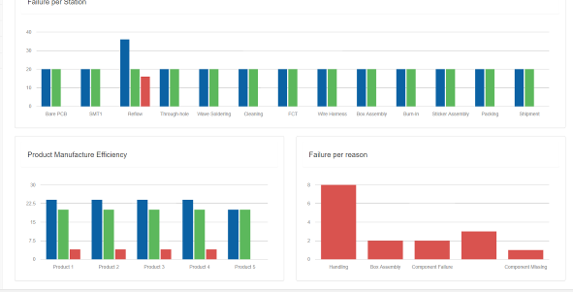

Three main statistical data is displayed.

Failure per station- displays the failure rates for each station. In the above example, reflow failed 16 times. So we can correct the problems at that station.

Product Manufacture Efficiency- displays the efficiency of manufacturing each type of product

Failure per reason-to display what kind of faults are the most common.

**5.6 Compare Builds**

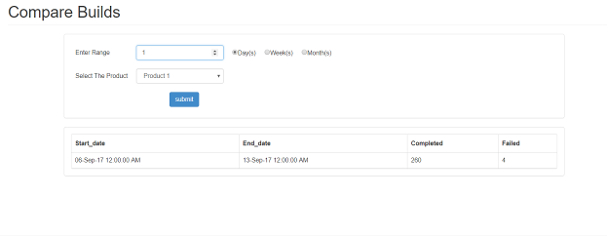

To compare between the different builds weekly, Daily or monthly and compare how much were completed/failed weekly daily or monthly.

**6. Notifications**

**6.1 Display Notification**

* Warning - particular device isn’t working
* Warning - failure rate of product is high
* Warning - particular station is faulty
* live data – each product finished
* live data – failure rate per station

**6.2 SMS Notification**

* Warning - device failure not solved
* Warning - failure of product not solved
* Warning - station fault not solved

**6.3 Email Notification**

* Warning - device failure rate high
* Warning - failure rate of product high
* Warning - station fault high
* EOD - Boards Completed
* EOD – Targets met
* EOD – failure rate

**7. Test Cases**

* Product is scanned more than once(rejected and accepted)- replaces the old data
* Even if product manufacturing order is different, Assurance of all process being completed till packing
* Stray barcodes are not saved(not having the same barcode precursor as a product being manufactured)
* If the product fails at one stage- the stage where it failed and reason for failure at that stage can be found
* Runs automatically when Wi-Fi, devices and PC is connected
* For the setup no constant internet connectivity is required. So no data lost when internet is off
* If any of the devices stop working for any reason, Client app displays it.
* Failure rate for specific product/station can be found
* Red LED glows when Barcode scanner is not connected or network problems
* Blue LED glows showing data is being transferred and green for barcode scanner picking up data
* Just first time setup
* USB port 1 is for normal barcode and port 2 for rejected barcode. They can be removed and inserted back at any time